**Educause 2018 Annual Conference in Denver Colorado**

**By Emily Ling, Architect, Classroom Design and Standard Officer, ACE Design Team | November 30, 2018**

What happens when you put thousands of Teaching and Learning Innovation Leaders and Higher Ed IT Professionals in the same place for one week? This October, Steve Bailey (Director, Academic + Campus Events) and I went to the Mile High City to attend the highly anticipated Educause 2018 Conference. There, we met with 8000+ professionals and technology providers from around the world to network, share ideas, grow professionally, and discover solutions to today’s challenges. This is the highlight of our trip:

**Day 1**

At the Pre-Conference Workshop Learning Space Design Jam facilitated by Adam Finkelstein (McGill), we feedback on each participants learning space designs to explore how design thinking can enhance the learning space design process. We learned from each other’s experience at updating classroom to better Teaching & Learning experience. Common concerns shared across Institutions were: Faculty Engagement, Ownership of classrooms, Budget and Funding, Policy, technological evolution.

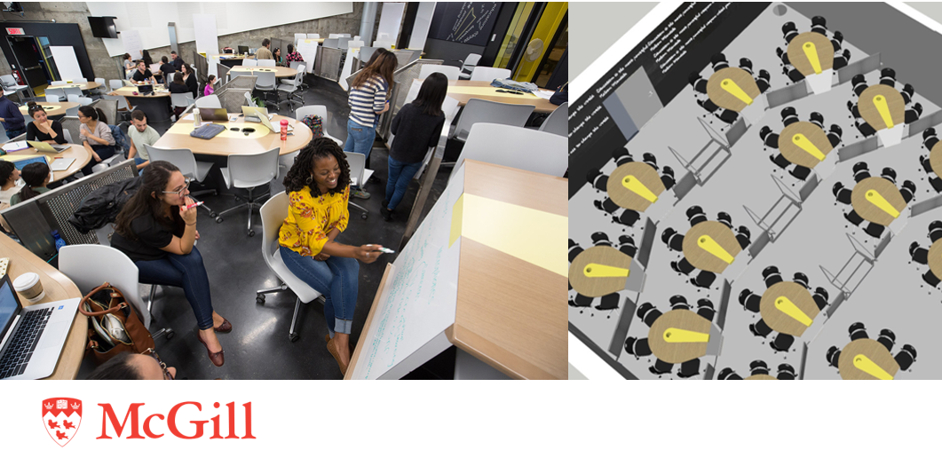

**Day 2**

During the Keynote Speech: Eavesdropping on America's - Conversation on Race, Michele Norris shared how her post-card pet project gained international awareness of racial issues through the use of website. Initially, Michele started the Race Card Project by mailing post cards to participants asking for six words to describe the individual’s idea of race, however, through the later use of website and social media, it became an international sensation that snapshots paint a vivid picture of America's attitudes and experiences about race during a fascinating moment in American history.

At Learning Space Design Community Group Session, the Learning Space Design leaders around the globe to discuss on topics from what makes a physical space conducive to learning to the principles/processes of effective learning space design. Each School shared ideas and experience on how formal and informal spaces impact teaching practices, learning activities, student interactions, and campus sense of community. ACE’s presentation of Myhal Centre for Engineering Innovation & Entrepreneurship attracted lots of attentions, that we are expecting many requests for tours in the up-coming months.

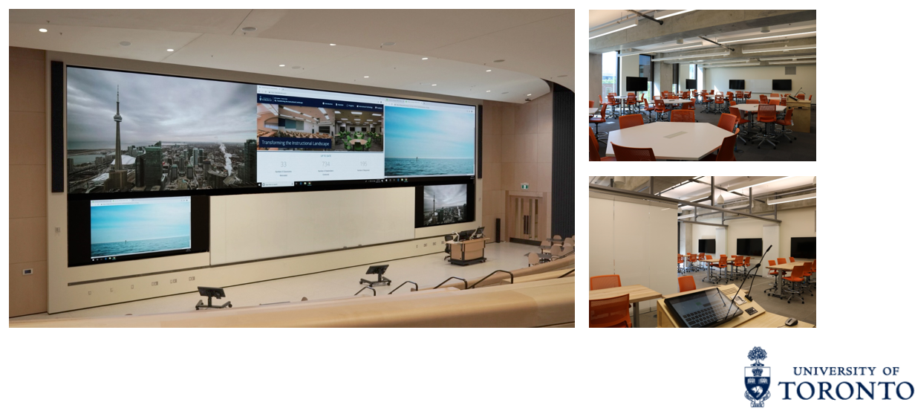

**Day 3**

John Augeri from Paris Digital University presented The Rise of Informal Learning Spaces: Design, Challenges, Assessment. This topic resonates to our hearts as ACE has been long campaigning to bring good design into not just classrooms (formal learning spaces), but also to the informal spaces around it. We understand learning is not limited in just within the walls of classrooms, students need quality space outside of classrooms for peer learning to exchange ideas and spark creativities.

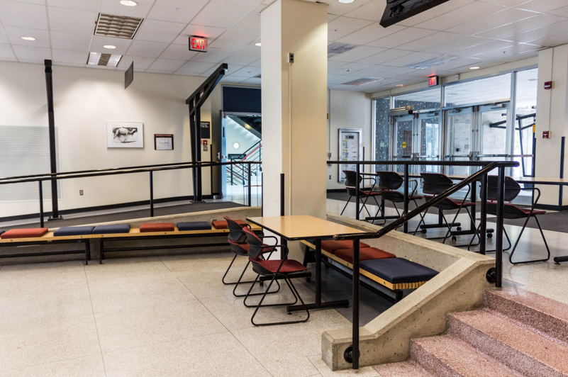 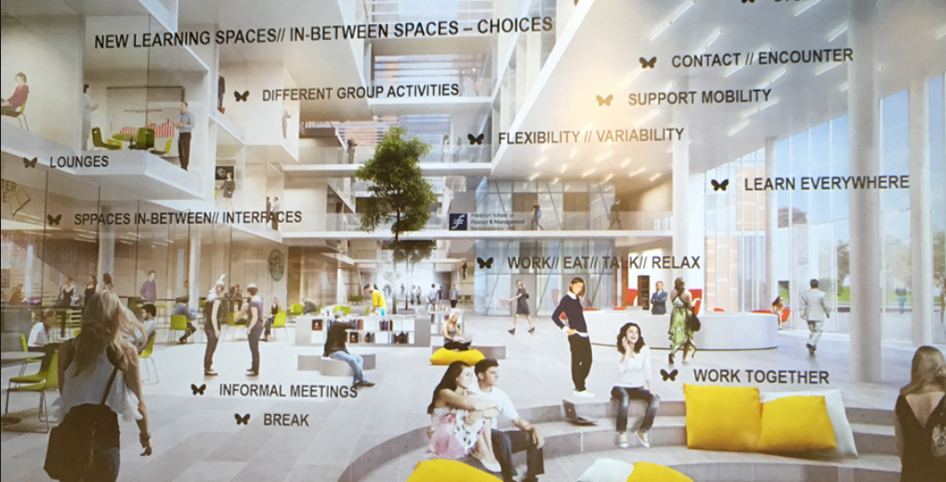

During the session of Implementing the LSRS (Learning Spaces Rating System) Across Campus: Multi-Institutional Perspectives, we explored the challenges and opportunities of how multiple institutions have used the LSRS to evaluate their entire classroom ecosystem. It is an in-depth discussion of how The Learning Space Rating System (LSRS) can help institutions measure their classrooms' potential to support active learning and can be used at all stages of planning and design. An example of how Harvard University uses the data to Evaluate a Pilot Project:

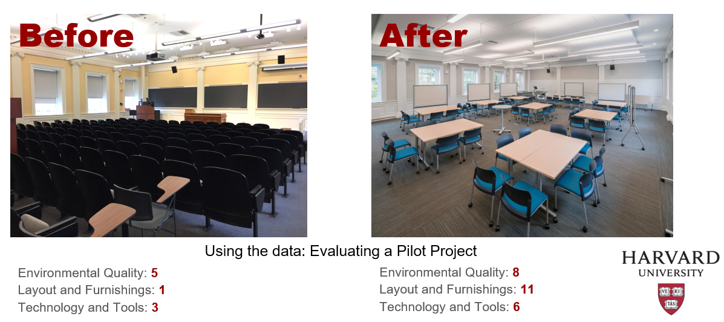

**Day 4**

On the last day, ACE attended Design Thinking: Leading Change Across Your Organization. This session explored implementation of Design Thinking across an organization. Design thinking defines, researches, ideates, prototypes, selects, and implements. We use this process as the cornerstone of creating user-centered opportunities to redesign our learning spaces.

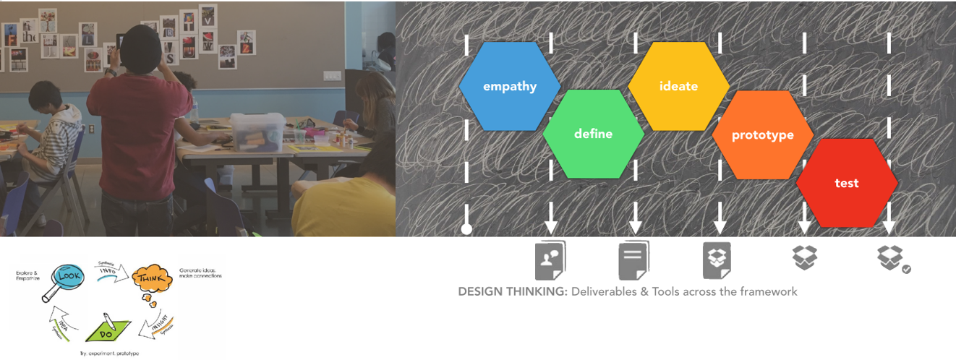

Before we headed to the airport, Steve and I were very lucky to run into Yan Tam-Sequin from UTM. A leading member at designing UTM’s Student Common, at spare time, Yan is an avid traveler. During the 1.5hr crush tour, she took us to Denver Milk Market District and Union Station. Both are recent downtown revitalization projects that celebrates the city’s history and local flavor.

